

VITYARTHI PROJECT
(FUNDAMENTALS OF AI AND ML)


TOPIC:- AI-Driven Expert Medical Diagnostic System

Technology Stack:- Python 3.x, Tkinter, SWI prolog
Submitted By:- Aryan Saxena
Registration number:- 25BCY10045
University Mail Id:- aryan.25bcy10045@vitbhopal.ac.in
Submitted on:- 24 November 2025

INTRODUCTION

The Hybrid Expert Diagnostic System used in this project is intended to give a patient a two-pronged evaluation based on two important symptoms: body temperature and duration of symptoms. The system combines a Symbolic AI (Prologue) component for rule-based diagnosis and treatment recommendation with a Machine Learning (ML) component for probabilistic risk assessment.
The main objective is to show how these two AI paradigms work together: the transparency and logical inference of rule-based systems, and the pattern recognition and prediction power of machine learning.

Problem Statement

Both probabilistic risk assessment and precise, rule-based clinical guidance are frequently needed for modern diagnostics. The challenge is to develop a single, cohesive system that can:
1. Use straightforward numerical patient inputs (duration and temperature).
2. Give a quick, data-driven Risk Category evaluation (Low, Medium, or High).
3. Use a predetermined set of expert rules to deduce a conclusive diagnosis and a treatment plan.
4. Use a user-friendly graphical user interface (GUI) to display these findings.

Functional Requirements (FR)

ID | Requirement Description | Source/Component
FR1 | The system shall accept Body Temperature (*C) and Symptom Duration (Days) as input. | app.py (GUI)
FR2 | The system shall validate input to ensure temperature >=35*C and duration > 0. | app.py
FR3 | The system shall load and train a Decision Tree classifier using symptoms_data.csv if the model file (risk_classifier.pkl) is missing. | app.py, classifier_model.py
FR4 | The system shall use the trained ML model to predict a Risk Category (Low, Medium, High) for the given inputs. | classifier_model.py
FR5 | The system shall translate numerical inputs into Prolog facts (fever\_high/fever\_low, duration\_long/duration\_short) based on defined thresholds. | app.py (Prolog Integration)
FR6 | The Prolog engine shall use the asserted facts to determine a Diagnosis (e.g., severe_infection, mild_viral_fever). | rules.pl
FR7 | The Prolog engine shall retrieve the corresponding Treatment Plan text for the determined diagnosis. | rules.pl
FR8 | The GUI shall display the ML Risk Assessment and the Prolog Diagnosis and Treatment Plan. | app.py (GUI)

Non-functional Requirements (NFR)

ID | Requirement Description | Category
NFR1 | Performance: The diagnosis and risk assessment should complete within 3 seconds of button press. | Time
NFR2 | Usability: The Tkinter GUI should be simple and intuitive for a non-technical user (e.g., a nurse or a patient self-assessment). | User Interface
NFR3 | Reliability: The Prolog engine must be initialized correctly, and input errors must be handled gracefully with clear messagebox alerts. | Error Handling
NFR4 | Maintainability: The diagnostic logic (rules) should be easily editable in the separate rules.pl file without altering the main Python code. | Modularity
NFR5 | Portability: The system requires external dependency on SWI-Prolog for the pyswip library to function. | Environment

System Architecture

The system uses a hybrid architecture that combines AI components that are knowledge-driven and data-driven.
1. Presentation Layer (app.py): User input is received and results are displayed by the Tkinter GUI.
2. Controller/Integration Layer (app.py): Serves as a bridge by contacting the ML service and using pyswip to communicate with the Prologue engine.
3. Machine Learning Service (classifier_model.py): In charge of training, storing, loading, and executing forecasts for Risk Category evaluation.
4-Expert System Engine (Prologue): The runtime inference engine (pyswip/SWI-Prolog) and knowledge base (rules.pl) utilised for symbolic diagnosis and treatment lookup.

Design Diagrams

To ensure that developers, testers, and product owners all have a common understanding of the application's architecture and behaviour, system modelling diagrams are essential.

Use Case Diagram

- Primary Actor: User/Patient
- Use Cases:
  - Enter Symptoms (Temperature, Duration)
  - Run AI Analysis
  - View Risk Assessment (ML Result)
  - View Diagnosis & Treatment (Prolog Result)

Workflow Diagram

Step | Component | Description
1. Start | User/GUI (app.py) | The user enters Body Temperature and Symptom Duration and clicks the "Run AI Analysis & Diagnosis" button.
2. Input Validation | app.py | The system checks if inputs are valid numbers and satisfy conditions( T>=35*C , D>0).
3. ML Risk Assessment | classifier_model.py | Python calls load_and_predict_risk(temp, duration). The loaded Decision Tree model predicts the Risk Category (Low, Medium, or High) based on the input data.
4. Display Risk | app.py | The GUI updates the Risk Assessment label, changing the color based on the category (e.g., Red for High, Green for Low).
5. Prolog Fact Setup | app.py | Python retracts old facts and asserts new facts (symptom/2) into the Prolog knowledge base based on thresholds.
6. Prolog Diagnosis Query | app.py | Python executes the query prolog.query("get_diagnosis(X, T)").
7. Rule Inference | rules.pl (Prolog Engine) | Prolog uses the asserted facts to satisfy the diagnosis/1 rules (e.g., severe_infection, mild_viral_fever). The get_diagnosis/2 rule links the diagnosis to the corresponding treatment/2 text.
8. Retrieve Results | app.py | Python receives the inferred Diagnosis and Treatment Plan text.
9. Display Results | app.py | The GUI updates the Diagnosis and Treatment labels with the results from the rule base.
10. End | System | The analysis is complete.

Sequence Diagram

Participant | Message
User | Enters Temp/Duration
:app.py (GUI) | temp, duration
:app.py | Calls load_and_predict_risk(temp, duration)
:classifier_model.py | Loads Model (risk_classifier.pkl)
:classifier_model.py | risk_category
:app.py | Updates GUI (Risk Label)
:app.py | prolog.retractall(...)
:app.py | prolog.assertz(symptom(patient, ...))
:app.py | prolog.query("get_diagnosis(X, T)")
:Prolog Engine | Performs Inference
:Prolog Engine | diagnosis, treatment
:app.py | Updates GUI (Diagnosis/Treatment)

Class/Component Diagram

- DiagnosticApp (app.py): Main controller, handles GUI, I/O, and integration.
  - Methods: run_diagnosis(), GUI setup.

- ClassifierModel (classifier_model.py): Handles data and ML logic.
  - Methods: load_data_and_train(), load_and_predict_risk().

- PrologEngine (rules.pl): Defines the knowledge base.
  - Predicates: symptom/2, diagnosis/1, treatment/2, get_diagnosis/2.

ER Diagram

The system does not use a relational database for persistent storage. The knowledge base is stored in the static Prolog file (rules.pl) and the data is loaded from a CSV file (symptoms_data.csv) for model training.

Design Decisions & Rationale

Decision | Rationale
Hybrid Approach (ML + Prolog) | Uses ML for fast, probabilistic risk prediction, and Prolog for transparent, logical diagnosis based on expert-defined rules.
Tkinter for GUI | Tkinter is lightweight, built-in to Python, and sufficient for this simple prototype, avoiding extra dependencies like PyQt or Kivy.
Decision Tree Classifier (ML) | Simple, fast to train on small datasets, and its decision logic is relatively interpretable, aligning with the rule-based theme.
Prolog Fact Assertion in Python | The Python code preprocesses the continuous numerical data into discrete symbolic symptoms (fever\_high, duration\_long) before querying Prolog, simplifying the rule logic in rules.pl.

Implementation Details

Language: Python 3.x for the application logic and GUI, Prolog for the expert knowledge base.
Libraries: tkinter, pyswip, scikit-learn, numpy, joblib.
Model Training: The classifier_model.py module handles model lifecycle. On the first run, app.py triggers load_data_and_train(), which saves the model to risk_classifier.pkl.
Thresholds:
- High Fever: Temp >= 39.0*C.
- Low Fever: 37.5*C <= TEMP < 39.0*C
- Long Duration: Duration >= 5 days

Screenshots / Results

(WITH USER INTERFACE)

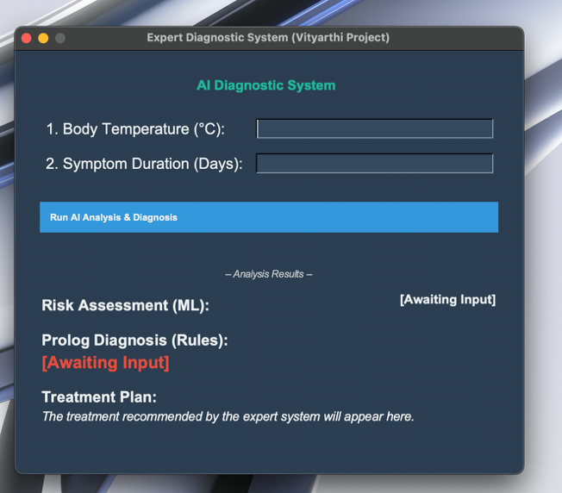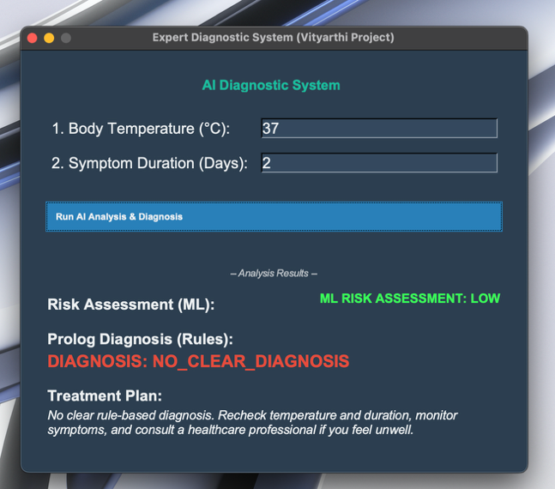

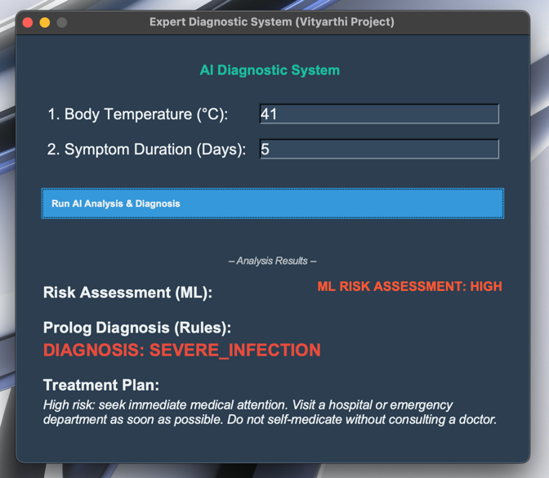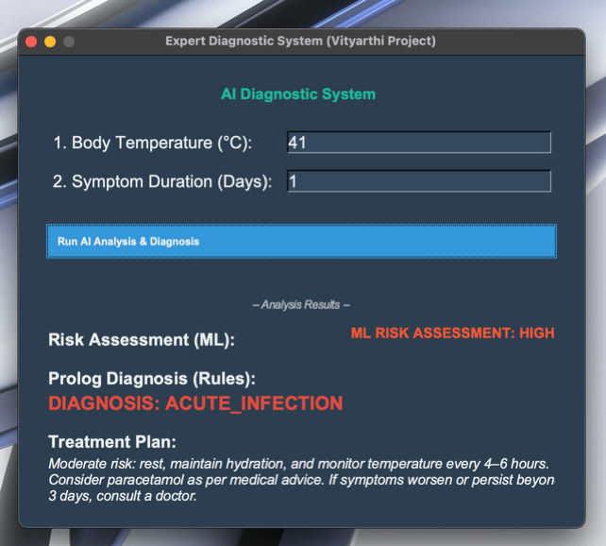
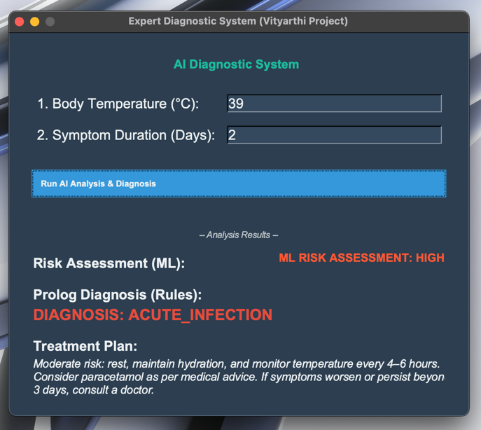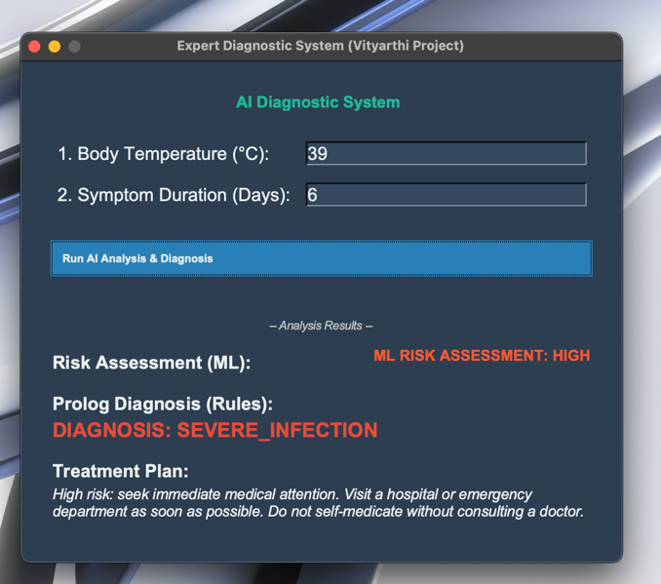

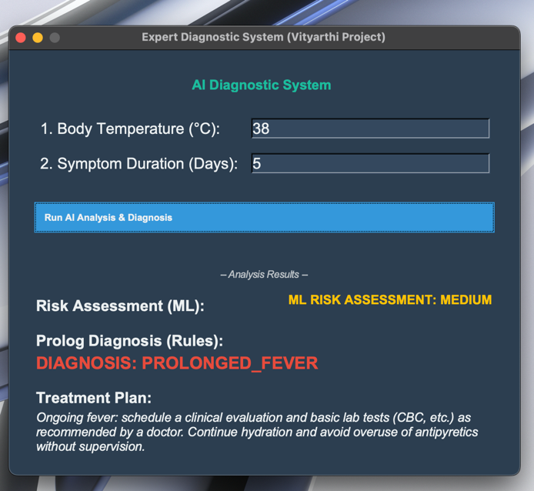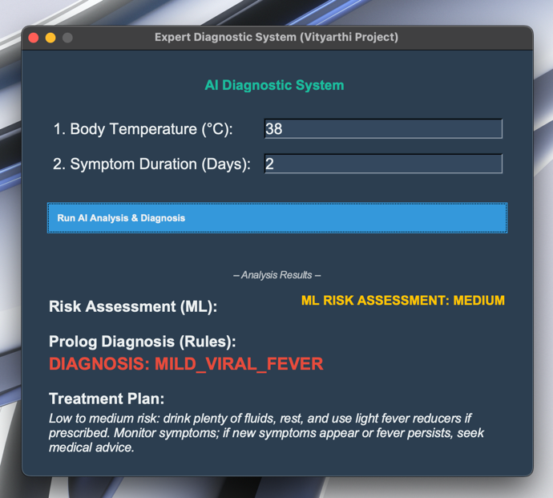

Testing Approach

Testing was primarily conducted using unit testing and scenario testing.
- ML Testing: Validated that the Decision Tree correctly predicts risk categories for boundary conditions in symptoms_data.csv. For example, 37.0*C, 1 day Low; 39.5*C, 6 days High.
- Prolog Rule Testing: Tested all four major diagnostic scenarios by simulating fact assertion from the Python side:
  - High Fever + Long Duration severe_infection.
  - High Fever + Short Duration acute_infection.
  - Low Fever + Short Duration mild_viral_fever.
  - Low Fever + Long Duration prolonged_fever.
- Integration Testing: Confirmed that the app.py successfully translates input, interacts with both the ML model and Prolog, and displays the correct combined output.

Challenges Faced

Prolog Initialization: Setting up the pyswip library required correct installation and path configuration for the external SWI-Prolog engine, which can be an external environment dependency issue.
Data Translation: The challenge was defining the correct thresholds (>= 39.0*C for fever\_high, >= 5 days for duration\_long) to effectively map continuous input data to discrete Prolog facts without loss of critical information.
Styling in Tkinter: Achieving a modern, consistent look (using the dark DiagnosticTheme) required manipulating the ttk.Style module, which is often less flexible than modern web frameworks.

Learnings & Key Takeaways

1. AI Hybridisation: Discovered the usefulness of integrating various AI approaches to address a single issue, such as using ML for data-driven risk assessment and symbolic AI for clear, rational decision-making (diagnosis).
2-Prolog Integration: Acquired expertise in dynamically asserting and retracting facts from a host language (Python) in a Prologue knowledge base, which is essential for creating stateful expert systems.
3. Model Deployment: Recognised the fundamental procedures for deploying a minimal machine learning model, which include training, saving (joblib), and loading for inference in a primary application.

Future Enhancements

  - Data and Model Complexity: For the risk assessment, use a larger, real-world dataset and a more sophisticated machine learning model (such as SVM or Logistic Regression).
  - Rich Symptom Input: To make the rule base more comprehensive, expand the input to include discrete symptoms (such as cough, headache, and fatigue) that would be directly asserted as Prologue facts.

  - Uncertainty Handling: Instead of depending solely on true/false rule matching, use fuzzy logic or certainty factors in Prologue to handle uncertain diagnoses.

  - Web/Mobile Deployment: For greater usability and accessibility, move the Tkinter GUI to a web framework (such as Flask or Django).

References

1:- Vityarthi Modules

2:- Language Reference for Python (https://docs.python.org/3/)
3:- SWI Prolog Official Documentation
4:- Tkinter Official Documentation (Widget parameters and methods reference)
5:- MVC Design Patterns and Object-Oriented Programming (OOP) (Conceptual framework)
6:- Documentation for the Tkinter Font Module (tkinter.font used for custom typography)

